ECON 101 – Macroeconomics
MIDTERM EXAM #1
EXAMINER: MUHEBULLAH KARIMZADA
February 12, 2026

Instructions:
1. You have 75 minutes to work on the exam.
2. This midterm is individual and closed-book.
3. For the multiple-choice questions, choose the option that best answers/completes the question.
4. This Examination paper includes 16 pages (includes the cover page). You are responsible for ensuring that your copy of the paper is complete. Bring any discrepancy to the attentions of your invigilator.

PLEASE: PUT YOUR NAME AND STUDENT ID ON EVERY SHEET!!
Multiple Choice Answers:

1. _________ 15. _________ 29. _________ 43. _________ 57. _________

2. _________ 16. _________ 30. _________ 44. _________ 58. _________

3. _________ 17. _________ 31. _________ 45. _________ 59. _________

4. _________ 18. _________ 32. _________ 46. _________ 60. _________

5. _________ 19. _________ 33. _________ 47. _________ 61. _________

6. _________ 20. _________ 34. _________ 48. _________ 62. _________

7. _________ 21. _________ 35. _________ 49. _________ 63. _________

8. _________ 22. _________ 36. _________ 50. _________ 64. _________

9. _________ 23. _________ 37. _________ 51. _________ 65. _________

10. _________ 24. _________ 38. _________ 52. _________

11. _________ 25. _________ 39. _________ 53. _________

12. _________ 26. _________ 40. _________ 54. _________

13. _________ 27. _________ 41. _________ 55. _________

14. _________ 28. _________ 42. _________ 56. _________

MULTIPLE CHOICE. Choose the one alternative that best completes the statement or answers the question.
1) The prevalence of Alzheimer's dementia is very high among residents living in nursing homes. A student concludes that it is likely that living in nursing home causes Alzheimer's dementia. What is the flaw in the student's reasoning?
A) The student is drawing a false conclusion by making the mistake of omitting the age of the residents.
B) The student is using an inadequate sample size.
C) The student has failed to take into account other causes of Alzheimer's disease.
D) The student is drawing a false conclusion; he is confusing cause and effect.
E) The student is drawing a false conclusion by making the mistake of omitting the gender of the residents.

2) Voluntary exchange between buyers and sellers generates ________ in a market economy.
A) equality
B) scarcity
C) productive efficiency
D) equity
E) allocative efficiency

3) ________ have a horizontal and a vertical axis and are used in economics to illustrate relationships between two economic variables.
A) Flow charts
B) Two-dimensional graphs
C) One-dimensional graphs
D) Pie charts
E) Bar graphs

4) Which of the following questions or statements regarding minimum wage is normative?
A) How do changes in minimum wages affect the employment opportunities of teens?
B) Higher minimum wages will cause firms to employ fewer people.
C) Wages play a role in causing someone to apply for a job.
D) People working in the retail sector deserve higher pay.
E) The minimum wage law causes unemployment.

5) A grocery store sells a bag of potatoes at a fixed price of $5.50. Which of the following is a term used by economists to describe the money received from the sale of an additional bag of potatoes?
A) marginal costs
B) marginal revenue
C) net benefit
D) gross earnings
E) pure profit

Scenario 1.1
Suppose a cell phone manufacturer currently sells 20,000 cell phones per week and makes a profit of $5,000 per week. A manager at the plant observes, "Although the last 3,000 cell phones we produced and sold increased our revenue by $6,000 and our costs by $6,700, we are still making an overall profit of $5,000 per week so I think we're on the right track. We are producing the optimal number of cell phones."

6) Refer to Scenario 1.1. Had the firm not produced and sold the last 3,000 cell phones, would its profit be higher or lower, and if so by how much?
A) Its profit will be $6,700 higher.
B) Its profit will be $6,000 lower.
C) Its profit will be $700 higher.
D) Its profit will be unchanged.
E) Its profit will be $700 lower.

7) The extra cost associated with undertaking an activity is called
A) marginal cost.
B) net loss.
C) activity cost.
D) opportunity cost.
E) foregone cost.

8) Making optimal decisions "at the margin" requires
A) making decisions according to one's whims and fancies.
B) weighing the costs and benefits of a decision.
C) advanced knowledge of economics.
D) making borderline decisions.
E) making consistently irrational decisions.

9) As professors and teachers get closer to retirement age they typically spend more time reading and thinking about the financial planning as well as the stock market. By gathering and using all available information as they act to achieve their goals, these teachers are exemplifying the economic idea that
A) people respond to economic incentives.
B) equity is more important than efficiency.
C) people make identical choices.
D) people are rational.
E) optimal decisions are made at the margin.

10) The relationship between consumer spending and disposable personal income is
A) an inverse relationship.
B) reverse causality.
C) independent.
D) a negative relationship.
E) a direct relationship.

11) The three fundamental questions that any economy must address are
A) Who gets jobs; what wages do workers earn; and who owns what property?
B) What goods and services to produce; how will these goods and services be produced; and who receives them?
C) How can the economy's output be equally shared; who are the decision makers; and what is the optimum output?
D) How much will be saved; what will be produced; and how can these goods and services be fairly distributed?
E) What will be the prices of goods and services; how will these goods and services be produced; and who will receive them?

Figure 2.10

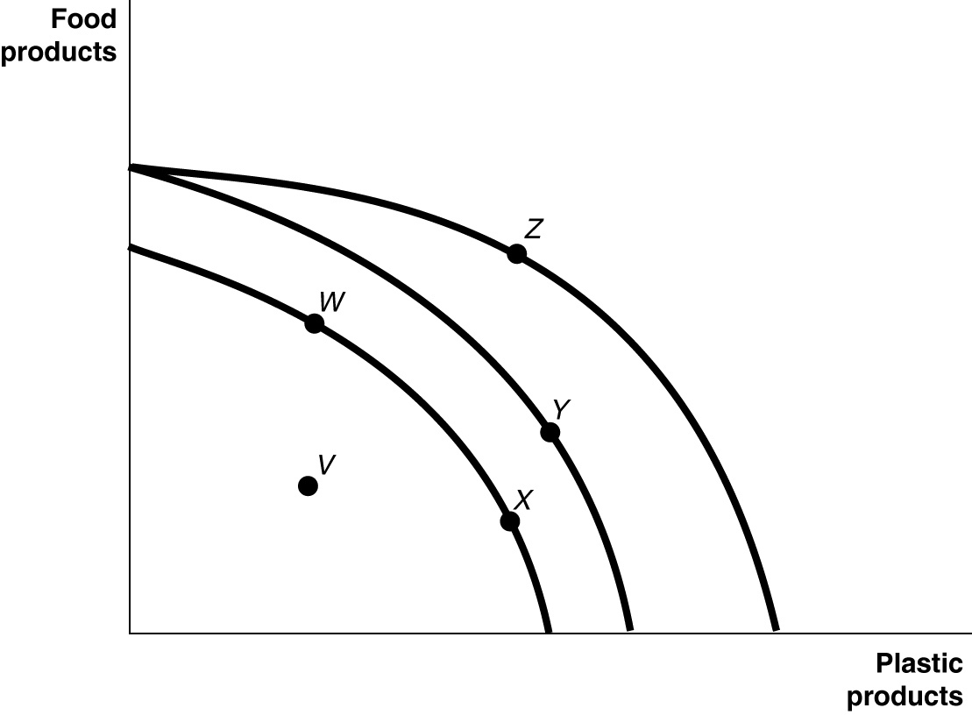

Figure 2.10 shows various points on three different production possibilities frontiers for a nation.

12) Consider the following events:
a. a decrease in the unemployment rate
b. general technological advancement
c. an increase in consumer wealth

Refer to Figure 2.10. Which of the events listed above could cause a movement from V to X ?
A) a only
B) b only
C) c only
D) a and c only
E) a, b, and c

13) A worker is hired in a(n)
A) factor market.
B) product market.
C) government market.
D) input market.
E) goods and services market.

14) A guild is
A) a group of nations who agree not to compete with each other.
B) a group of independent producers competing with each other.
C) an intergovernmental organization.
D) a nation that is a free market benchmark.
E) an organization of producers that limits the amount of a good produced.

15) If opportunity costs are ________, the production possibilities frontier would be graphed as a negatively sloped straight line.
A) negative
B) positive
C) decreasing
D) constant
E) increasing

16) If the production possibilities frontier is ________, then opportunity costs are constant as more of one good is produced.
A) vertical
B) linear
C) bowed out
D) nonlinear
E) bowed in

Table 2.6
 | One Digital Camera | Wheat (per pound)
China | 100 hours | 4 hours
South Korea | 60 hours | 3 hours

Table 2.6 shows the number of labour hours required to produce a digital camera and a pound of wheat in China and South Korea.

17) Refer to Table 2.6. What is China's opportunity cost of producing one digital camera?
A) 0.04 pounds of wheat
B) 4 pounds of wheat
C) 25 pounds of wheat
D) 40 pounds of wheat
E) 100 pounds of wheat

Figure 2.13
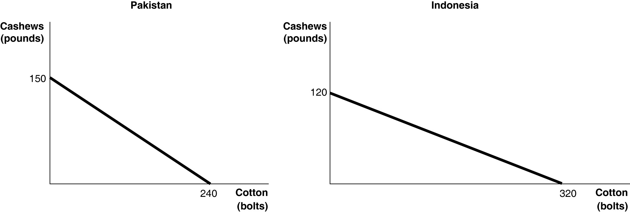

Figure 2.13 shows the production possibilities frontiers for Pakistan and Indonesia. Each country produces two goods, cotton and cashews.

18) Refer to Figure 2.13. What is the opportunity cost of producing 1 bolt of cotton in Indonesia?
A) 3/8 of a pound of cashews
B) 5/8 of a pound of cashews
C) 2 2/3 pounds of cashews
D) 120 pounds of cashews
E) 320 pounds of cashews

Figure 2.5

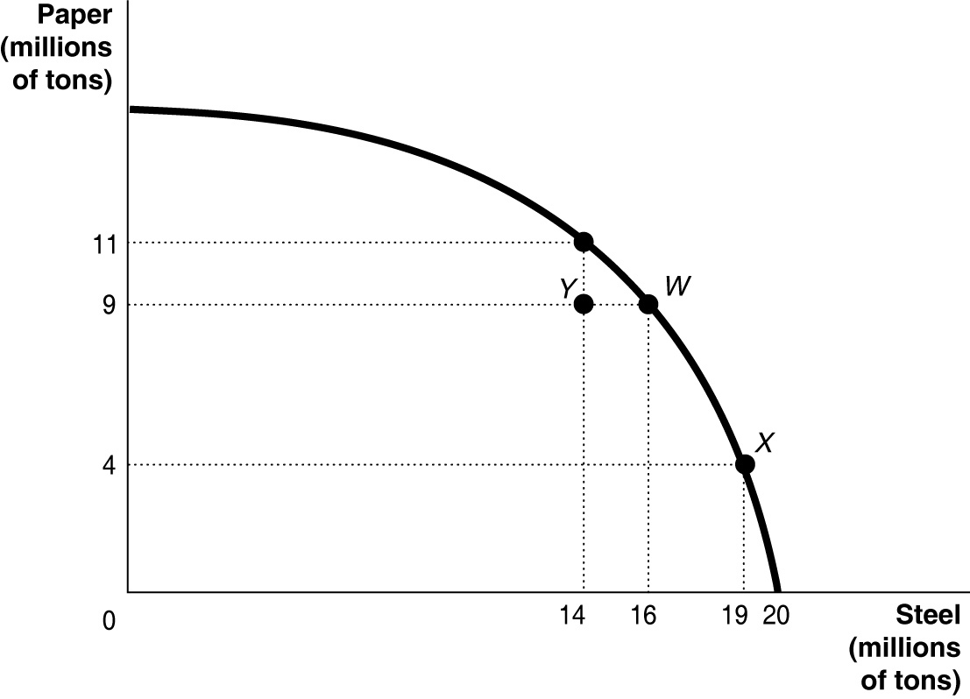

19) Refer to Figure 2.5. If the economy is currently producing at point W, what is the opportunity cost of moving to point X?
A) 5 million tons of paper
B) 9 million tons of paper
C) 19 million tons of steel
D) 3 million tons of steel
E) zero tons of paper and steel

20) If the production possibilities frontier is linear, then
A) all points on the linear line are inefficient, as only a curve is efficient.
B) opportunity costs are decreasing as more of one good is produced.
C) opportunity costs are increasing as more of one good is produced.
D) it is easy to efficiently produce output.
E) opportunity costs are constant as more of one good is produced.

Table 2.6
 | One Digital Camera | Wheat (per pound)
China | 100 hours | 4 hours
South Korea | 60 hours | 3 hours

Table 2.6 shows the number of labour hours required to produce a digital camera and a pound of wheat in China and South Korea.

21) Refer to Table 2.6. What is China's opportunity cost of producing one pound of wheat?
A) 0.04 units of a digital camera
B) 4 digital cameras
C) 25 digital cameras
D) 40 digital cameras
E) 60 digital cameras

Table 2.3

Production Choices for Dina's Diner
Choice | Quantity of Sliders Produced | Quantity of Hot Wings Produced
A | 80 | 0
B | 60 | 25
C | 40 | 50
D | 20 | 75
E | 0 | 100

22) Refer to Table 2.3. Assume Dina's Diner only produces sliders and hot wings. A combination of 40 sliders and 25 hot wings would appear
A) along Dina's production possibilities frontier.
B) inside Dina's production possibilities frontier.
C) outside Dina's production possibilities frontier.
D) at the vertical intercept of Dina's production possibilities frontier.
E) at the horizontal intercept of Dina's production possibilities frontier.

23) The production possibilities frontier shows the ________ combinations of two products that may be produced in a particular time period with available resources.
A) minimum attainable
B) equitable
C) maximum attainable
D) many and various
E) restricted and only

24) If a demand curve shifts to the right, then
A) demand has increased.
B) quantity demanded has decreased.
C) quantity demanded has increased.
D) demand and quantity demanded have stayed the same.
E) demand has decreased.

25) In January, buyers of gold expect that the price of gold will rise in February. What happens in the gold market in January, holding all else constant?
A) The supply curve shifts to the right.
B) The demand curve shifts to the right.
C) The demand curve shifts to the left.
D) The quantity demanded increases.
E) The supply and demand curves will remain unchanged.

Figure 3.1

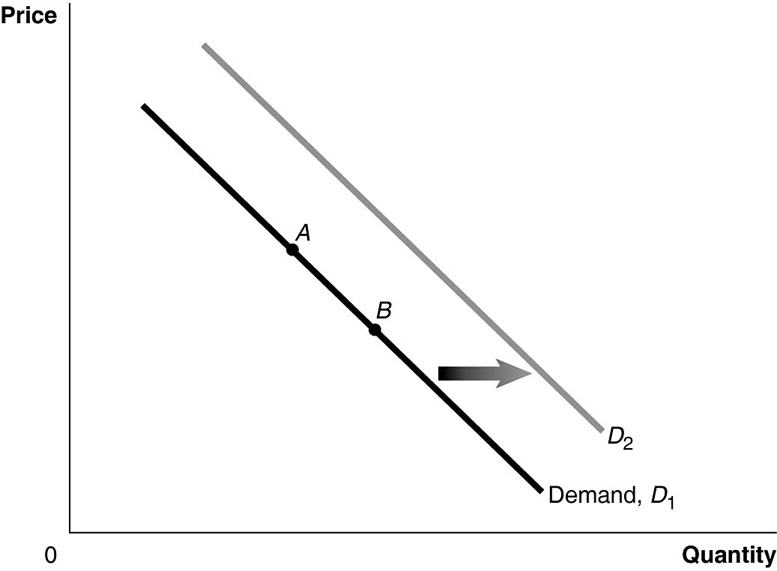

26) Refer to Figure 3.1. If the product represented is an inferior good, an increase in income would be represented by a movement from
A) A to B.
B) B to A.
C) D1 to D2.
D) D2 to D1.
E) 0 to A.

27) Which of the following is the correct way to describe equilibrium in a market?
A) At equilibrium, market forces no longer apply.
B) At equilibrium, surpluses are greater than shortages.
C) At equilibrium, scarcity is eliminated.
D) At equilibrium, quantity demanded equals quantity supplied.
E) At equilibrium, demand equals supply.

28) If the demand for Sidney Crosby hockey cards is greater than the demand for Jacques Plante hockey cards, what would have to be true for the market equilibrium prices for these hockey cards to be equal?
A) The supply of Crosby hockey cards would have to be less than the supply of Plante hockey cards.
B) The supply of Plante hockey cards would have to be less than the supply of Crosby hockey cards.
C) The demand of Crosby hockey cards would have to be less than the demand of Plante hockey cards.
D) The supply of Crosby hockey cards and the supply of Plante hockey cards would have to be equal.
E) If the demand for Crosby hockey cards is greater than the demand for Plante hockey cards, the market equilibrium price for Crosby hockey cards will always be greater than the market equilibrium price for Plante hockey cards.

29) Which of the following statements is true?
A) If demand decreases and supply increases, one cannot determine if equilibrium price will increase or decrease without knowing which change is greater.
B) An increase in demand causes a change in equilibrium price; the change in price does not cause a further change in demand or supply.
C) A decrease in supply causes equilibrium price to rise; the increase in price then results in a decrease in demand.
D) If both demand and supply increase, there must be an increase in equilibrium price; equilibrium quantity may either increase or decrease.
E) An increase in supply causes equilibrium price to fall; the decrease in price then results in an increase in demand.

30) Olive oil producers want to sell more olive oil at a higher price. Which of the following events would have this effect?
A) an increase in the price of land used to plant olives
B) an increase in the number of olive oil producers
C) Research finds that consumption of olive oil reduces the risk of heart disease.
D) an increase in the price of olive oil presses
E) a decrease in the cost of transporting olive oil to markets

Figure 3.12

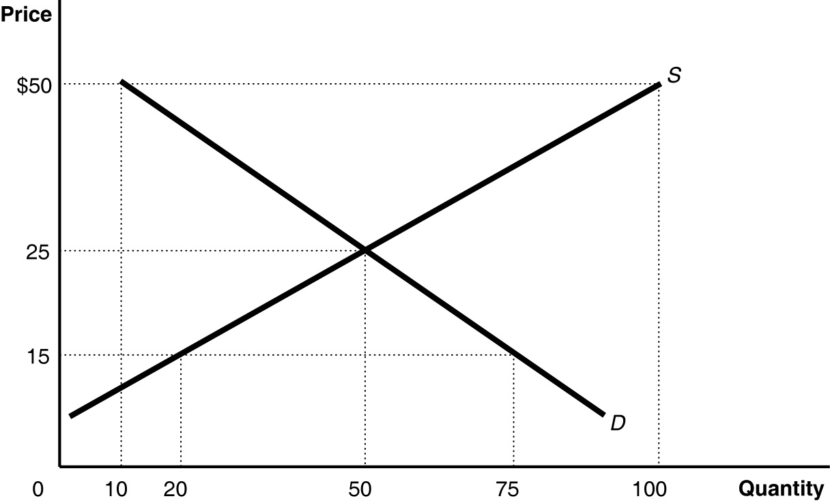

31) Refer to Figure 3.12. The figure above represents the market for coffee grinders. Assume that the market price is $21. Which of the following statements is true?
A) There is a shortage that will cause the price to decrease; quantity demanded will then increase and quantity supplied will decrease until the price equals $25.
B) There is a shortage that will cause the price to increase; quantity supplied will then decrease and quantity demanded will increase until the price equals $25.
C) There is a surplus that will cause the price to decrease; quantity supplied will then increase and quantity demanded will decrease until the price equals $25.
D) There is a shortage that will cause the price to increase; demand will then decrease and supply will increase until the price equals $25.
E) There is a shortage that will cause the price to increase; quantity demanded will then decrease and quantity supplied will increase until the price equals $25.

Figure 3.6
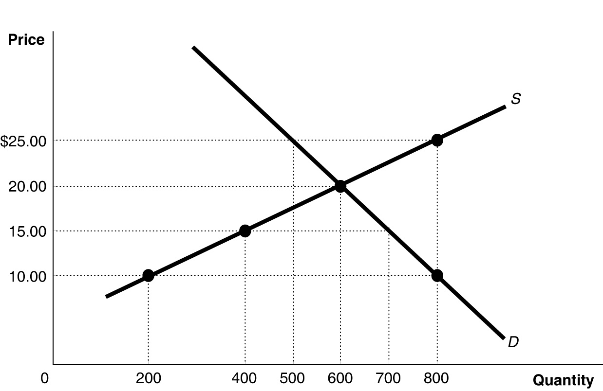

32) Refer to Figure 3.6. If the current market price is $10, the market will achieve equilibrium by
A) a price decrease, decreasing the supply and decreasing the demand.
B) a price decrease, decreasing the quantity supplied and increasing the quantity demanded.
C) a price decrease, decreasing the supply and increasing the demand.
D) a price increase, increasing the supply and decreasing the demand.
E) a price increase, increasing the quantity supplied and decreasing the quantity demanded.

33) If, in the market for oranges, the supply has increased, then
A) the supply curve for oranges has shifted to the left.
B) the supply curve for oranges has shifted to the right.
C) the supply curve for oranges has stayed the same.
D) there has been a movement upwards along the supply curve for oranges.
E) there has been a movement downwards along the supply curve for oranges.

Table 4.11
Year | Guns Produced | Price of Guns | Butter Produced | Price of Butter
2012 | 80 | $5 | 40 | $4
2019 | 90 | 6 | 60 | 10

Consider the above data for Tyrovia, a country that produces only two products: guns and butter.

34) Refer to Table 4.11. Real GDP for Tyrovia for 2019 using 2012 as the base year equals
A) $1,140.
B) $880.
C) $690.
D) $560.
E) $320.

35) Disposable household income equals household income
A) plus government transfer payments.
B) plus interest payments.
C) minus government transfer payments plus personal tax payments.
D) minus personal tax payments.
E) minus personal tax payments plus government transfer payments.

Table 4.20
 | 2018 |  | 2020
Product | Quantity | Price | Quantity | Price
Cameras | 100 | $10 | 120 | $12
Legal services | 50 | 15 | 45 | 20
Books | 200 | 40 | 210 | 45

A very simple economy produces three goods: cameras, legal services, and books. The quantities produced and their corresponding prices for 2018 and 2020 are shown in the table above.

36) Refer to Table 4.20. What is the GDP deflator in 2020 if 2020 is the base year?
A) 120
B) 118
C) 100
D) 87
E) 78

37) The output of Canadian citizens who work in the United States would be included in the
A) gross domestic product of Canada.
B) gross national income of the United States.
C) gross national income of the United States and the gross national product of Canada.
D) gross domestic product of both countries.
E) gross domestic product of the United States.

38) Which of the following would not be included in final consumption when calculating GDP using the expenditure approach?
A) furniture
B) a house
C) automobile
D) clothing
E) refrigerator

39) Which of the following are included in gross domestic product for an economy in a given year?
A) the value of used goods sold in that year
B) the value of intermediate goods produced in that year
C) the value of final goods produced in that year
D) the value of stocks and bonds sold to finance the building of new factories
E) All of the above would be included in gross domestic product for an economy in a given year.

40) Which of the following equations correctly measures GDP in an economy?
A) GDP = C + NI + G + NX
B) GDP = C + G + I - taxes
C) GDP = C + I + G + NX
D) GDP = C + I + G + X
E) GDP = C + I + G + NX + wages

41) Net National Income equals Gross National Income minus
A) changes in inventories.
B) imports.
C) depreciation.
D) exports.
E) inventories.

42) When U.S. GDP grows more slowly compared to Canada,
A) Canadian firms will invest more, causing domestic investment to rise and Canadian GDP to fall.
B) Canadian firms will export less, leading to slower Canadian GDP growth.
C) government spending in Canada will likely decrease.
D) Canadians will export some of the newly made Canadian goods, causing U.S. GDP to shrink.
E) Canadian prices will rise more quickly causing household disposable income to fall in Canada.

43) Real GDP will increase
A) only if the price level rises.
B) only if the quantity of final goods and services produced rises.
C) when nominal GDP falls.
D) only if the price level falls.
E) if either the price level rises or the quantity of final goods and services produced rises.

44) Suppose that nominal GDP in 2020 was less than real GDP in 2019. Given this information, we know for certain that
A) the price level in 2020 was greater than the price level in the base year.
B) real GDP in 2020 was less than real GDP in the base year.
C) real GDP in 2020 was greater than real GDP in the base year.
D) the price level in 2020 was less than the price level in the base year.
E) real GDP in 2020 was equal to real GDP in the base year.

45) The size of the underground economy would tend to increase if the government of a country
A) legalized marijuana.
B) increased income tax rates.
C) legalized prostitution.
D) decreased government regulations on businesses.
E) decreased sales taxes.

46) Presently, GDP is ________ to compensate for the costs of environmental damage.
A) not adjusted
B) partially adjusted
C) fully adjusted
D) adjusted using base year values of environmental quality
E) adjusted on a chain-weight basis

47) When the labour market is at full employment,
A) there is only structural unemployment in the economy.
B) there is no cyclical unemployment in the economy.
C) there is only cyclical unemployment in the economy.
D) frictional unemployment is less than 2%
E) the unemployment rate is 0%.

48) If the minimum wage is set above the market wage,
A) frictional unemployment will increase.
B) the quantity of labour supplied will be below the quantity of labour demanded.
C) unemployment will rise.
D) highly-skilled workers will have a harder time finding jobs.
E) All of the above are correct.

49) Upon your graduation from university, you find that the economy is in recession and the unemployment rate is relatively high. Nonetheless, you continue along your career path looking for a new job because
A) recessions typically last longer than it takes to complete a second university degree.
B) looking for work is your only option.
C) the wages of university graduates do not fall during recession.
D) high unemployment rates do not usually last for very long.
E) the cost of additional education is always higher during recession.

50) Which of the following would increase the unemployment rate?
A) an increase in employment insurance payments
B) a decrease in the minimum wage
C) a law making it illegal to work more than 35 hours per week
D) a cut in employment compensation
E) a period of high economic growth

51) The Employment Insurance program has which of the following effects?
A) It increases the amount of time spent searching for a job.
B) It reduces structural unemployment.
C) It decreases the amount of personal income of the unemployed.
D) It lowers the overall unemployment rate.
E) It contributes to the severity of a recession or economic downturn.

52) In the modern Canadian economy, the typical unemployed person stays unemployed for
A) an amount of time that is hard to quantify.
B) a relatively long time, over a year.
C) a relatively short time, less than 13 weeks.
D) a permanent time.
E) a long time during expansions and short time during recessions.

53) Since 1976, the labour force participation rate for adult men has ________ and for adult women has ________.
A) decreased; remained constant
B) increased; decreased
C) decreased; increased
D) increased; increased
E) remained constant; increased

54) Which of the following explains the changes in the Canadian adult male labour force participation rate since 1976?
A) There are fewer working age males than in the past.
B) Younger men are remaining in school longer as compared to the past.
C) Fewer men consider themselves discouraged workers as compared to the past.
D) More men are joining the military as compared to the past.
E) More men are retiring later in life as compared to the past.

55) The most important group not identified by the unemployment rate is
A) part-time workers seeking full-time work.
B) students.
C) seniors.
D) those under the minimum working age.
E) discouraged workers.

56) The advice to "keep searching, there are plenty of jobs around here for which you are qualified," would be most appropriate for which of the following types of unemployment?
A) frictional unemployment
B) seasonal unemployment
C) geographical unemployment
D) structural unemployment
E) cyclical unemployment

57) In December 2015, CHCH TV laid-off 129 employees from its local news division. If these lay-offs occurred because advertisers cut back their spending due to a slowdown in the economy, the former local news division workers would be classed as
A) not in the labour force.
B) frictionally unemployed.
C) cyclically unemployed.
D) structurally unemployed.
E) seasonally unemployed.

58) The short-term unemployment arising from the process of matching workers with jobs is called
A) frictional unemployment.
B) structural unemployment.
C) cyclical unemployment.
D) seasonal unemployment.
E) unnatural unemployment.

59) An economic model is a simplified version of reality used to analyze real-world economic situations.
A) True
B) False

60) In a free market there are virtually no restrictions, or at best few restrictions on how factors of production can be employed.
A) True
B) False

61) To increase fuel efficiency, automobile manufacturers make cars small and light. Large cars absorb more of the impact of an accident than small cars but yield lower fuel efficiency. These facts suggest that a negative relationship exists between safety and fuel efficiency.
A) True
B) False

62) If the demand for a product increases and the supply of the same product decreases, the equilibrium price will increase.
A) True
B) False

63) Scarcity is defined as the situation that exists when the quantity demanded for a good is greater than the quantity supplied.
A) True
B) False

64) Paying efficiency wages are a way for a company to cut costs and become more efficient, and are therefore lower than market wages.
A) True
B) False

65) Most economists believe that labour unions significantly increase the overall unemployment rate in Canada.
A) True
B) False

